**Lesson 03 Demo 06**

**Product Roadmap Using MIRO**



**Objective:** To build a product roadmap using Miro AI

**Tools required:** Miro AI

**Prerequisites:** None

A collaborative platform for team brainstorming, SWOT analysis, and product road mapping

**Steps to be followed:**

1. Go to [Miro.com](https://miro.com/templates/)
2. Choose the product roadmap template and create your account
3. Go to the Miro Assist and describe your product and resources
4. Generate the product roadmap
5. Create a map based on resources and timeline
6. Enter the generated plans in their respective fields of the map
7. Convert the planning into a presentation
8. Download or share the planning map and presentation

**Product Description:**

Create a product roadmap for a mobile phone company that involves coordinating across multiple teams such as product design, development, marketing, and sales to bring an idea to life and into the market.

**Step 1: Go to Miro.com**

**Step 2: Choose the product roadmap template and create your account**

* 1. Enter your email details and sign up for free

It will redirect you to the home page, where a template is prebuilt.

* 1. Choose the prebuilt Product Roadmap Template on Miro

**Step 3: Go to the Miro Assist and describe your product and resources**

* 1. Click on the **Miro Assist button**

* 1. Describe your product and resources to the Miro Assist

**Step 4: Generate the product roadmap**

Generate a product roadmap based on the product information provided to Miro Assist.

**Step 5: Create a map based on resources and a timeline**

**Step 6: Enter the generated plans in their respective fields of the map**



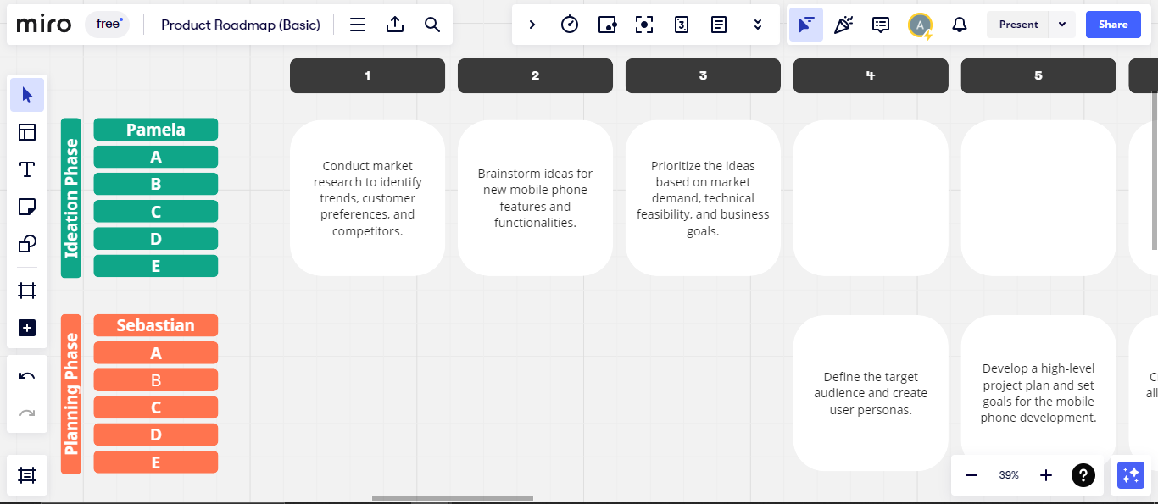

**Step 7: Convert the planning into a presentation**

Transform the completed planning and strategies into a presentation format by clicking on **Chat reply** and choosing **Presentation**

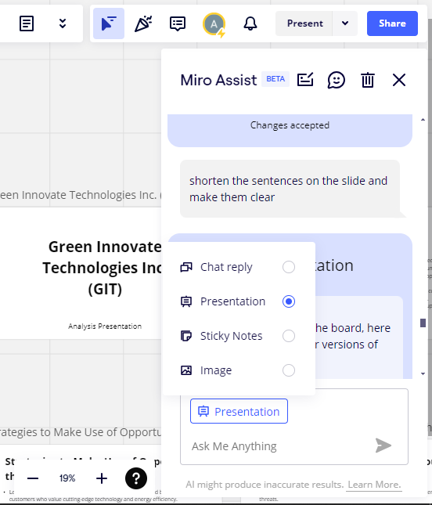

**Step 8: Download or share the planning map and presentation**

**